- 找到“目录”位置
- 更改样式为如下图：
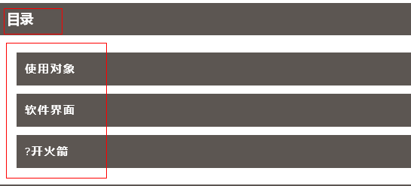
模板：
<!DOCTYPE html>
<html xmlns="http://www.w3.org/1999/xhtml">

<head>
<meta http-equiv="Content-Type" content="text/html; charset=UTF-8">
<meta http-equiv="X-UA-Compatible" content="IE=edge">
<meta name="viewport" content="width=device-width, initial-scale=1">
<link rel="stylesheet" media="screen" href="../css/yhsc.css">
<script src="../js/angularjs.js"></script>
<script src="../js/menus.js"></script>
<script src="../js/mui.min.js"></script>

</head>
<body >
<h4 title="Click to Open / Close" class="h" ng-click="menuClick($event)" id="T01">目录</h4>
<div class="outer" style="display: block;">
<div class="inner">
<div ng-repeat="child in parent.childNames" class="ng-scope">
<a href="html/G001.html" class="ng-binding">开车</a>
</div>
<div ng-repeat="child in parent.childNames" class="ng-scope">
<a href="html/G002.html" class="ng-binding">开飞机</a>
</div>
<div ng-repeat="child in parent.childNames" class="ng-scope">
<a href="html/G003.html" class="ng-binding">开火箭</a>
</div>
</div>
</div>
..........

</body>
</html>

- 把原word转成的html中，目录的超链接和文字保留，
超链接一般是“#_TocXXXX”
文字中包含&#9，可快速找到
如下：
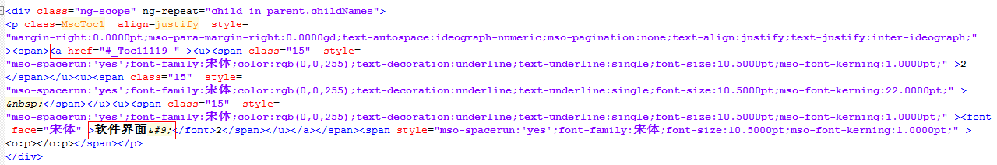
- 把保留的插到模板中
